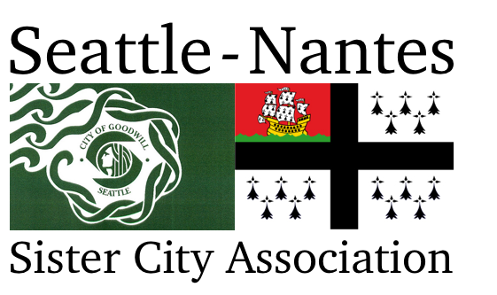

seattle-nantes.org | facebook.com/seattlenantessca | twitter.com/seattlenantes | seattlenantessca@gmail.com
Dr. Thomas H. Bennett Scholarship

Seattle-Nantes Sister City Association formed in 1980 as a nonprofit citizen diplomacy network whose goals are to create and strengthen partnerships between Seattle and Nantes in an effort to increase global cooperation at the municipal level, and promote cultural understanding. The scholarship program is one extension of SNSCA’s mission.

The scholarship was established in 2019 in memory of Dr. Thomas H. Bennett, longtime Association member and Board President who deeply valued academia and the experience of travel. Through his involvement in SNSCA, he made frequent trips to Nantes and enjoyed many friendships in our beloved sister city. He had an integral role in growing the Association’s scholarship program. Fittingly, the scholarship bearing his name honors candidates who will travel to a francophone country to pursue French studies. The scholarship will award up to $1500 to high school or college students.

Requirements
- Is a high school or college student during the 2020-2021
- Will study abroad in a francophone country
- Has a passion for the French language, learning, and travel

Preference
- Is a Washington State resident

Candidates are responsible for submitting a complete application by the deadline of February 1, 2021. A complete application consists of the Candidate Information form, personal essay, a current official transcript, and two letters of recommendation. Applications can be submitted to seattlenantessca@gmail.com or Seattle-Nantes Scholarships, c/o Alaina McCallum, 215 13th Ave E, Apt 203, Seattle, WA 98102.

Scholarship recipients will receive a free one-year membership to Seattle-Nantes Sister City Association and will be expected to an active member by participating in activities and projects, serving on the board, or making presentations to the membership.

Certification and Permission to use Candidate Information to announce Scholarship Recipients

In submitting this application, I certify that the information provided is complete and accurate to the best of my knowledge. Falsification of information may result in termination of any scholarship granted.

I agree that if I am offered and accept an award from Seattle-Nantes Sister City Association and its affiliated programs may use my name and photo, the name of my school, the amount of the award, and the name of the postsecondary institution I will attend in press releases, public announcements, and other fundraising or promotional materials in all media to advance the mission of Seattle-Nantes Sister City Association and its affiliated programs.

Candidate’s Signature _____________________________________________ Date ___________________
Parent Signature (if student is under 18 years of age) ______________________________________________
Scholarships are awarded without regard to age, sex, marital status, race, creed, color, religion, national origin, or the presence of any mental, sensory, or physical handicaps. Financial resources may be considered in some cases.
Candidate Information

Last name: | First name: |  | Middle initial:
Address:
Street City State Zip code
Phone number: |  | Email address:
High School attended: |  | Graduation date:
Postsecondary school: |  | Year of study during 2021-21:
Intended major: |  | Anticipated date of graduation:

Position and Employer | Responsibilities | Date
Relevant Experience: Describe any relevant experience during the past four years.

Activity | Participation and Responsibilities | Date
Activities and Community Engagement: Describe any activities and community engagement during the last four years.

Recommendations: Please list who your two recommendations are from and their relationship to you.
Name ______________________________________________ Relationship to you ______________________
Name ______________________________________________ Relationship to you ______________________
Personal Essay
Please type the personal essay with a limit of 500 words.

The Thomas H. Bennett Scholarship is awarded to candidates who will study in a francophone country.

With the scholarship criteria and the mission of Seattle-Nantes Sister City Association in mind, please respond to the question, what experiences have already shaped you and how do you envision your experience in the francophone country will have on you?

Letter of Recommendation
To be completed by a high school or college teacher.

Name of Candidate _______________________________

You have been asked to provide information in support of this candidate for the Dr. Thomas H. Bennett Scholarship. Seattle-Nantes Sister City Association awards the Scholarship to a candidate who will study in a francophone country.

Please give attention to the candidate’s achievements, quality of commitment to school and community, and scholarly work. Include comments on the candidate’s achievement in French language and passion for the learning and traveling.

Please email the letter of recommendation by February 1, 2021 to seattlenantessca@gmail.com or mail it to Seattle-Nantes Scholarships, c/o Alaina McCallum, 215 13th Ave E, Apt 203, Seattle, WA 98102.

Letter of Recommendation
To be completed by a high school or college teacher.

Name of Candidate _______________________________

You have been asked to provide information in support of this candidate for the Dr. Thomas H. Bennett Scholarship. Seattle-Nantes Sister City Association awards the Scholarship to a candidate who will study in a francophone country.

Please give attention to the candidate’s achievements, quality of commitment to school and community, and scholarly work. Include comments on the candidate’s achievement in French language and passion for the learning and traveling.

Please email the letter of recommendation by February 1, 2021 to seattlenantessca@gmail.com or mail it to Seattle-Nantes Scholarships, c/o Alaina McCallum, 215 13th Ave E, Apt 203, Seattle, WA 98102.

