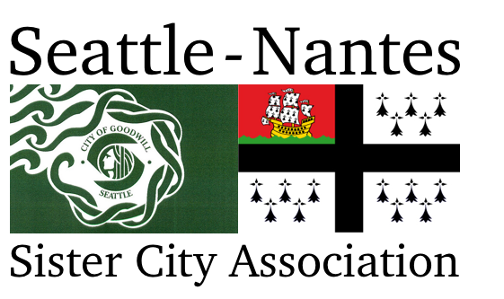

Frances Bennett Scholarship
seattle-nantes.org | facebook.com/seattlenantessca | twitter.com/seattlenantes | seattlenantessca@gmail.com

Seattle-Nantes Sister City Association formed in 1980 as a nonprofit citizen diplomacy network whose goals are to create and strengthen partnerships between Seattle and Nantes in an effort to increase global cooperation at the municipal level, promote cultural understanding, and stimulate economic development. The scholarship program is one extension of SNSCA’s mission.

Frances Bennett became fascinated with French language and culture as a little girl and began taking French classes when she was old enough. She had to drop out of her first year of university due to polio. Despite doctors’ predictions, she survived the disease and was able to pass on her love of French to her children, grandchildren, and great-grandchildren by reading them her favorite French books. Seattle-Nantes Sister Cities Association will award a Frances Bennett Scholarship of up to $1,500 to a student who has a passion for the French language and culture and wants to pass on their love of French to others.

This will be demonstrated in the written application, as well as in an interview during which selected applicants will also be asked to answer a few questions in French.

Requirements
- Enrollment in a French class at a college or university in Washington in the 2021-2022 academic year
- Passion for French language and culture
- Intention to enter a service profession (eg. teaching, medicine) or overcame significant hardship to pursue studies

Preference
- A major in French or Francophone studies, or a minor in French or take at least two full years of courses, or a concentration in French to support a program of study

Candidates are responsible for submitting a complete application by the deadline of February 1, 2021. A complete application consists of the Candidate Information form, personal essay, a current official transcript, and two letters of recommendation. Please submit applications can be submitted to seattlenantessca@gmail.com or Seattle-Nantes Scholarships, c/o Alaina McCallum, 215 13th Ave E, Apt 203, Seattle, WA 98102.

Scholarship recipients will receive a free one-year membership to Seattle-Nantes Sister City Association and will be expected to an active member by participating in activities and projects, serving on the board, or making presentations to the membership.

Certification and Permission to use Candidate Information to announce Scholarship Recipients

In submitting this application, I certify that the information provided is complete and accurate to the best of my knowledge. Falsification of information may result in termination of any scholarship granted.

I agree that if I am offered and accept an award from Seattle-Nantes Sister City Association and its affiliated programs may use my name and photo, the name of my school, the amount of the award, and the name of the postsecondary institution I will attend in press releases, public announcements, and other fundraising or promotional materials in all media to advance the mission of Seattle-Nantes Sister City Association and its affiliated programs.

Candidate’s Signature _____________________________________________ Date ___________________
Parent Signature (if student is under 18 years of age) ______________________________________________
Scholarships are awarded without regard to age, sex, marital status, race, creed, color, religion, national origin, or the presence of any mental, sensory, or physical handicaps. Financial resources may be considered in some cases.
Candidate Information

Last name: | First name: |  | Middle initial:
Address:
Street City State Zip code
Phone number: |  | Email address:
High School attended: |  | Graduation date:
Postsecondary school: |  | Year of study during 2021-21:
Intended major: |  | Anticipated date of graduation:

Position and Employer | Responsibilities | Date
Relevant Experience: Describe any relevant experience during the past four years.

Activity | Participation and Responsibilities | Date
Activities and Community Engagement: Describe any activities and community engagement during the last four years.

Recommendations: Please list who your two recommendations are from and their relationship to you.
Name ______________________________________________ Relationship to you ______________________
Name ______________________________________________ Relationship to you ______________________
Personal Essay
Please type the personal essay with a limit of 500 words.

The Frances Bennett Scholarship is awarded to candidates who have a passion for the French language and culture and want to pass on their love of French to others. The scholarship honors candidates who plan to enter a service profession such as teaching or medicine or have overcome significant hardship in order to continue their studies.

With the criteria for the scholarship and the mission of Seattle-Nantes Sister City Association in mind, how are you planning to integrate French language and culture into your educational objectives?

Letter of Recommendation
To be completed by a high school or college teacher.

Name of Candidate _______________________________

You have been asked to provide information in support of this candidate for the Frances Bennett Scholarship awarded by the Seattle-Nantes Sister City Association. The Frances Bennett Scholarship is awarded to candidates who have a passion for the French language and culture and want to pass on their love of French to others. The scholarship honors candidates who plan to enter a service profession such as teaching or medicine or have overcome significant hardship in order to continue their studies.

Please give attention to the candidate’s achievements, quality of commitment to school and community, and scholarly work. Include comments on the candidate’s achievement in French language and passion for French culture, interpersonal skills, and leadership.

Please email the letter of recommendation by February 1, 2021 to seattlenantessca@gmail.com or mail it to Seattle-Nantes Scholarships, c/o Alaina McCallum, 215 13th Ave E, Apt 203, Seattle, WA 98102.
Letter of Recommendation
To be completed by a high school or college teacher.

Name of Candidate _______________________________

You have been asked to provide information in support of this candidate for the Frances Bennett Scholarship awarded by the Seattle-Nantes Sister City Association. The Frances Bennett Scholarship is awarded to candidates who have a passion for the French language and culture and want to pass on their love of French to others. The scholarship honors candidates who plan to enter a service profession such as teaching or medicine or have overcome significant hardship in order to continue their studies.

Please give attention to the candidate’s achievements, quality of commitment to school and community, and scholarly work. Include comments on the candidate’s achievement in French language and passion for French culture, interpersonal skills, and leadership.

Please email the letter of recommendation by February 1, 2021 to seattlenantessca@gmail.com or mail it to Seattle-Nantes Scholarships, c/o Alaina McCallum, 215 13th Ave E, Apt 203, Seattle, WA 98102.

